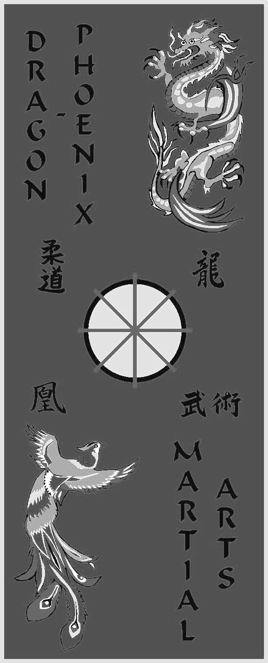

The 34th Alliance Tournament

Dragon Phoenix
Martial Arts

Chelmsford & Natick, MA

Kenpo Academy
of Self Defense

Derry & Salem, NH &
Methuen, MA

Sunday, May 4th, 2025

Londonderry High School

295 Mammoth Rd, Londonderry NH
Student Application Form
Name:___________________________________ Age: __________ DOB: ______/_____/______

Address: _________________________________ City: ____________ State: ______ Zip:________

Phone:______________________ E-mail address:__________________________________________

Height:_______________ Weight: _______________ Studio:_________________________________

Self Defense Partner Name:________________________ Age:________ Rank: _________________

EVENTS RANK AGE
□Traditional Forms □White □Blue/Stripe □ 5-↓ □ 14-17
□Weapons Forms* □Yellow □Green □ 6-7 □ 18-34
□Musical Forms □Orange □Green/Stripe □ 8-9 □ 35+
□Sparring (Male)* □Purple □Brown □ 10-13
□Sparring (Female)* □Blue □Black
□Junior Blade Novice
*Please Note

Self Defense: Partners must be the same age and rank category. Bring your own weapons.

Sparring: bring your own gear:
head, hands, kicks, mouthguard and groin protector (male) are required.

Weapons Forms: bring your own weapon.
□Adult Blade (18+) Intermediate
□Self Defense* Advanced
PRE-REGISTERED ENTRY FEE: FIRST TWO EVENTS : $50,
EACH ADDITIONAL EVENT : +$5
BLADE FIGHTING ONLY : $20
LATE ENTRY: +$10 (Applications received at the door)
Please make checks payable to your school

**SPECTATOR TICKETS at the door: $10 (Under 5’s Free)**

In consideration of your acceptance of my entry, I do hereby for myself, my heirs, executors and administrators, waive, release and discharge ALLIANCE TOURNAMENTS and/or it’s departments, officers, agents, representatives, successors and/or assigns and against any participants for any and all damages which may be sustained by me in connection with my association with or entry in the athletic meet, or which may arise out of my traveling to, participating in, or returning from said athletic event. Alliance Tournaments reserves the right to publish any photographs taken at the event for publicity and/or promotional purposes.

SIGNATURE (PARENT/GUARDIAN IF UNDER 18): __________________________ Date:_____/_____/____
I hereby give permission to the attending physician or medical personnel to treat _______________in the event of
an emergency.
Insurance carrier:_____________________ Policy Number_________________ Signature__________________
For further details please call Shihan Jesse Dwire, Dragon Phoenix Martial Arts, Chelmsford, MA (978) 250-1422 or Hanshi Lenny Demers, Kenpo Academy of Self Defense, Londonderry, NH (603) 948-0645

Make checks out to Kenpo Academy and mail them to Kenpo Academy 123 Nashua rd unit 36&36 Londonderry N.H. 03053

